Name _______________________________________
Worksheet 3 Plotting

- Data can be encoded in several different aspects of a plot. Name as many of these as you can (e.g., the horizontal axis)

- What aspects of a plot are useful for encoding discrete data? What about continuous data?

- What makes this a good plot and what makes this a bad plot?
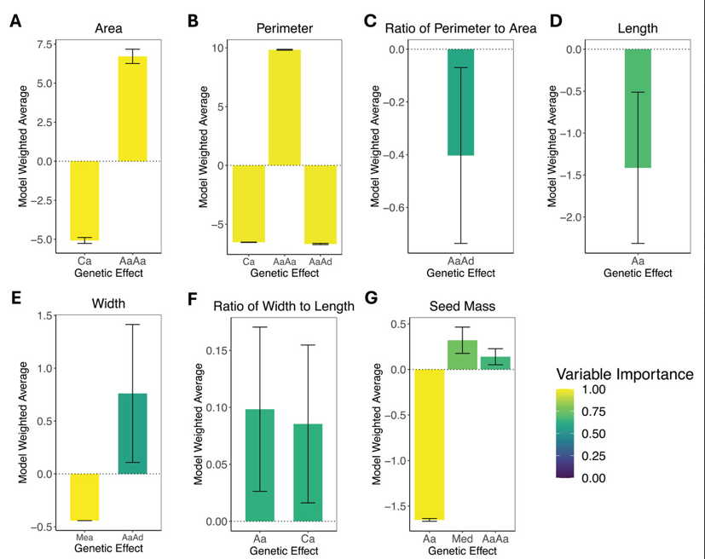

- What makes this a good/bad plot
